|  |  |  |
| --- | --- | --- |
| |  | | --- | | Discrete Structure Assignment Probability | |  |   **Dr. Muhammad Ahmad** |

|  |
| --- |
|  |

**National University of Computer & Emerging Sciences Department of Computer Science**

**General Guidelines**

1. Peer plagiarism and the late submissions are strictly not allowed

2. Total Marks: 100

3. Your assignment submission must be in hardcopy (i.e., handwritten, or printed form)

4. Deadline (As mentioned on Google Classroom)

5. QUESTIONS MUST BE IN ORDER. NO OUT OF ORDER QUESTION WILL BE MARKED.

# Question No 1

**Construct MST of given graph step by step (otherwise no marks will be awarded) explain each step with a sentence or two. Also find its cost.**

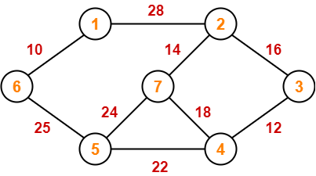

# Question No 2

**Apply prims algorithms on the following graph step by step (otherwise no marks will be awarded) explain each step with a sentence or two.**

# Question No 3

**a) Does the given graph have a Hamilton path? If it does, find it. If it does not give the reason for its non-existence.**

**b) Does the given graph have a Hamilton circuit? If it does, find it. If it does not give the reason for its non-existence.**

# Question No 4

**Does each of these lists of vertices form a path in the following graph? Which paths are simple? Which are circuits? What are the lengths of those that are paths?**

**a) a, b, e, c, b**

**b) a, d, a, d, a**

**c) a, d, b, e, a**

**d) a, b, e, c, b, d, a**

# Question No 5

**For which values of ‘n’ is a Kn graph bipartite?**

**s Where Kn is a complete graph and n is the number of vertices.**

# Question No 6

**Assume that we have 5 vertices with degrees 4,2,2,1,3. Draw its graph. Step by step and explain each step with a sentence or two.**

# Question No 7

**Find Hamiltonian circuit. Step by step and explain each step with a sentence or two.**

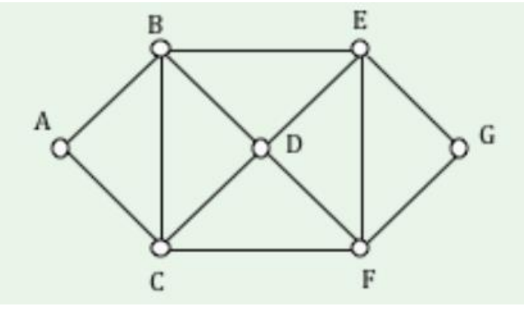

# Question No 8

**Find if graph has Eulers circuit or not. And give reasons.**

# Question No 9

**Explain which of the following are the Bipartite Graph and which are not.**

# Question No 10

**How much storage is needed to represent a simple graph with n vertices and m edges using the following:**

[Provide proper reason/calculation for each]

a) adjacency lists?

b) an adjacency matrix?

Also explain what technique to use when graph is dense and sparse.